Power BI

**Assignment – 2**

**• Connect to the Store Sales Data and do the following**

Connected Sales Data in to the power BI Desktop successfully post downloading the same from the canvas dashboard and performed below steps as suggested.

**Q1 − Remove all the blank rows.**

A – Post loading the data source/File in to the power BI Desktop, We need to follow below steps to remove the blanks from the workbook if any.

Step - 1: Load the source file using **Get Data** option for different source file, If the source file is an excel file we can directly load the source file by clicking **Excel** option under home page.

Step - 2: Post Data/File Load completes Power BI Desktop application automatically popups the **Power Query Editor page** where we can perform some data transformations based on the requirement **post selecting the table from the right side of the query editor** page and then we need to click on **Transform Data** Option.

Step - 3: If the workbook contains any blanks can be removed by following below path.

**Home >> Remove Rows (Reduce Rows Section) >> Click on Remove Blank Rows**

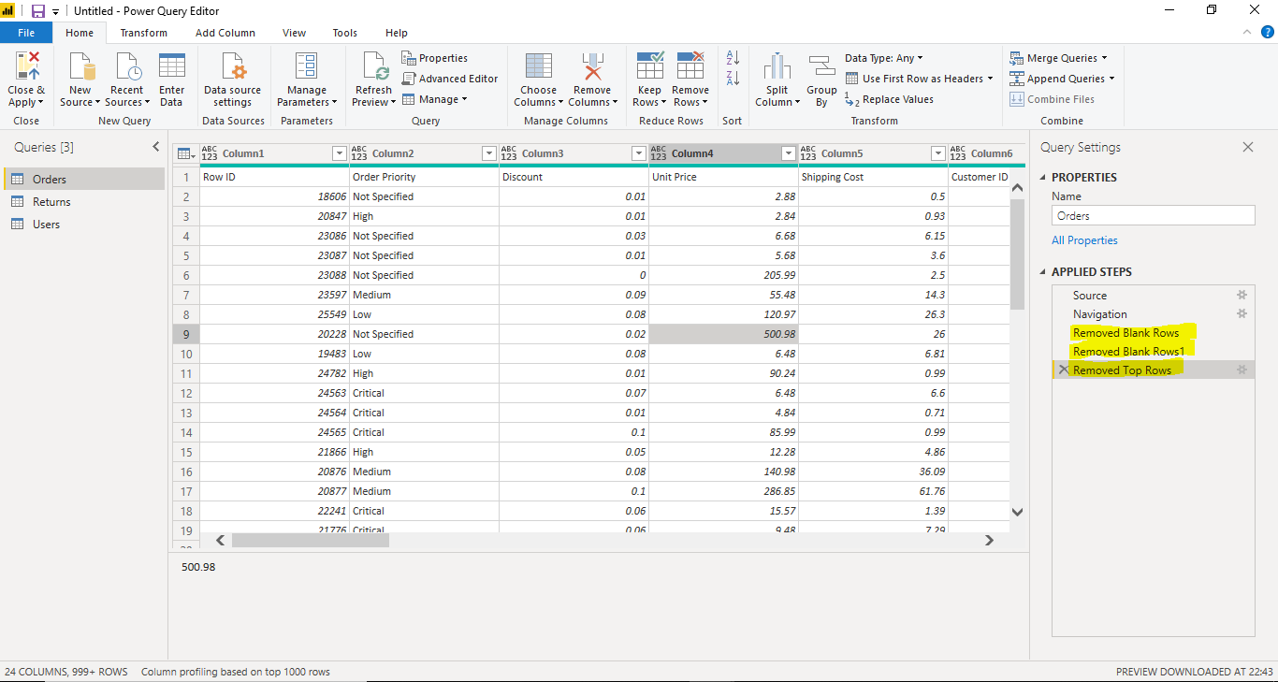

**Q2 − Update the column header if they are not updated**

**A – Column Headers can be updated in the workbook if not updated using Power BI Desktop by following below steps.**

**Home >> Use First Row as Headers (Transform Section) >> select - Use first row as headers option**

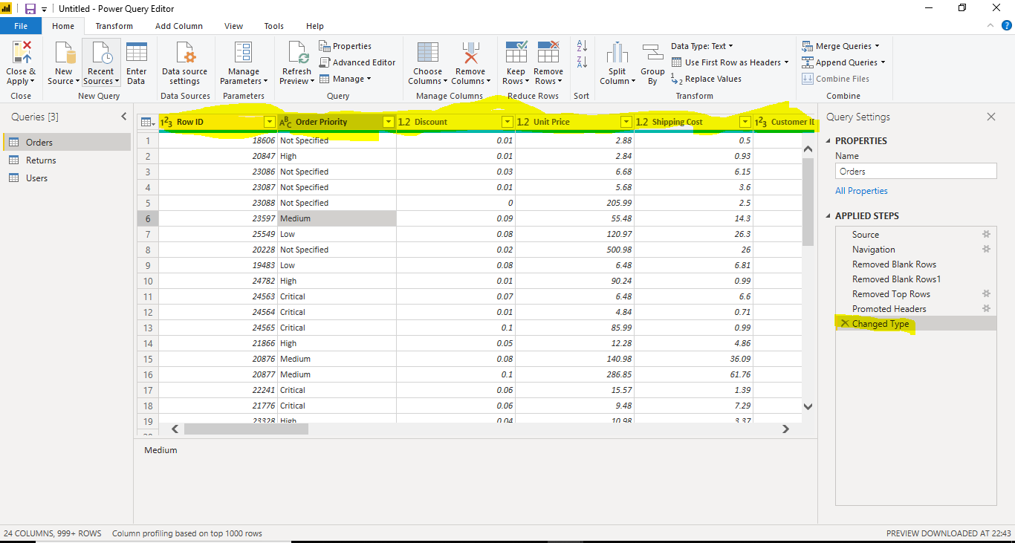

**− Create a text table and show the sales in terms off (Customers, Product Category, and Regions)**

**A – Text Table can be created under visualization category in power BI Desktop and as suggested sales table created as per mentioned category and slicers have been placed for filtering the data based on conditions.**

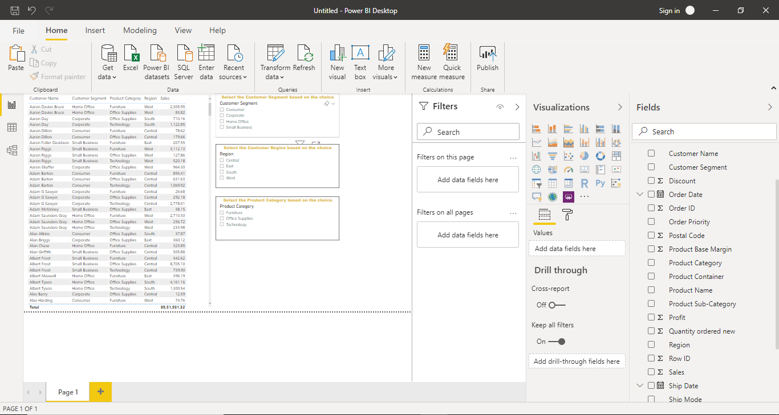

**Q2 • Create a line and Clustered Column Chart showing the Sales and Discount as per the State or Province.**

− Format the bars and line with different colours

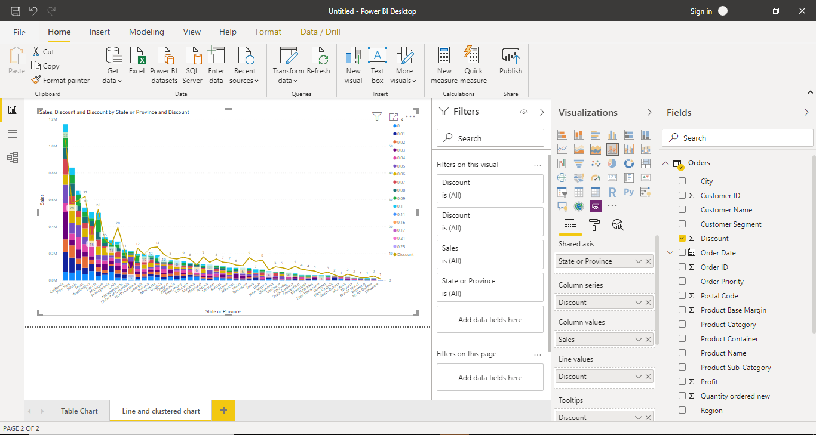

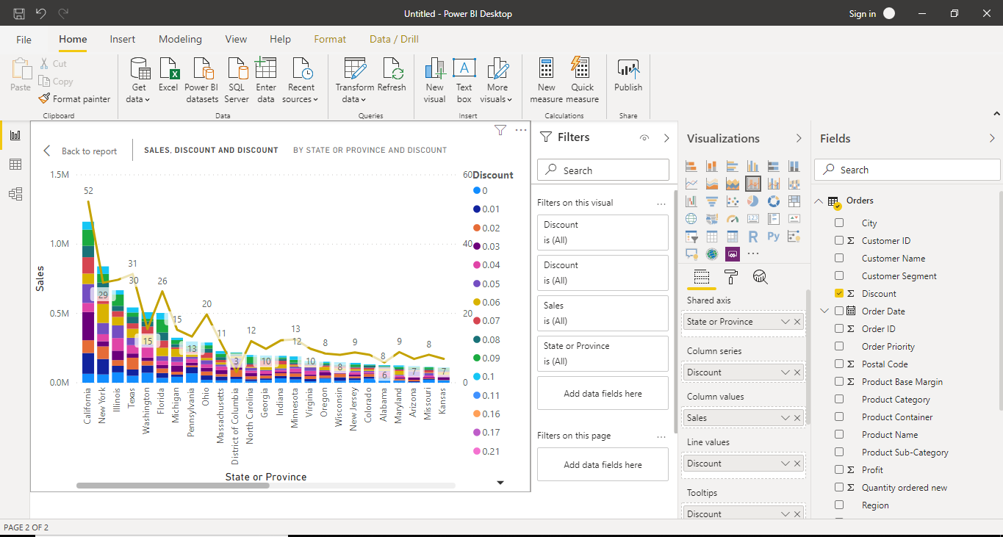

**− Which state has the highest sales in terms Technology?**

A - New York State has the highest profit ($81,110,87) in terms of sales in technology

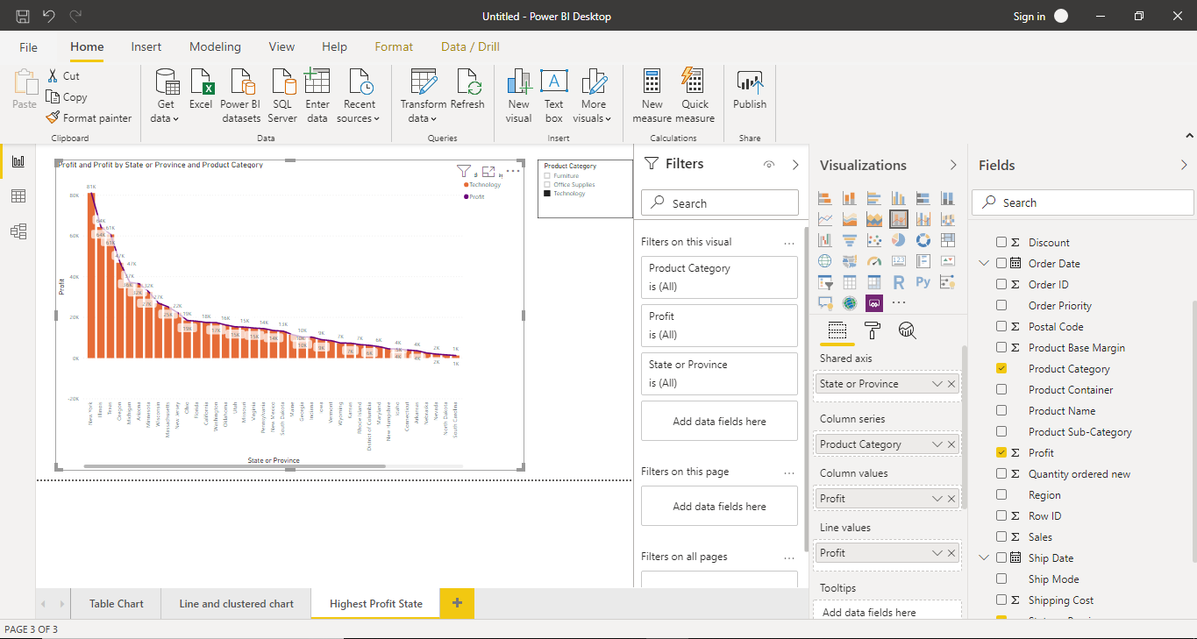

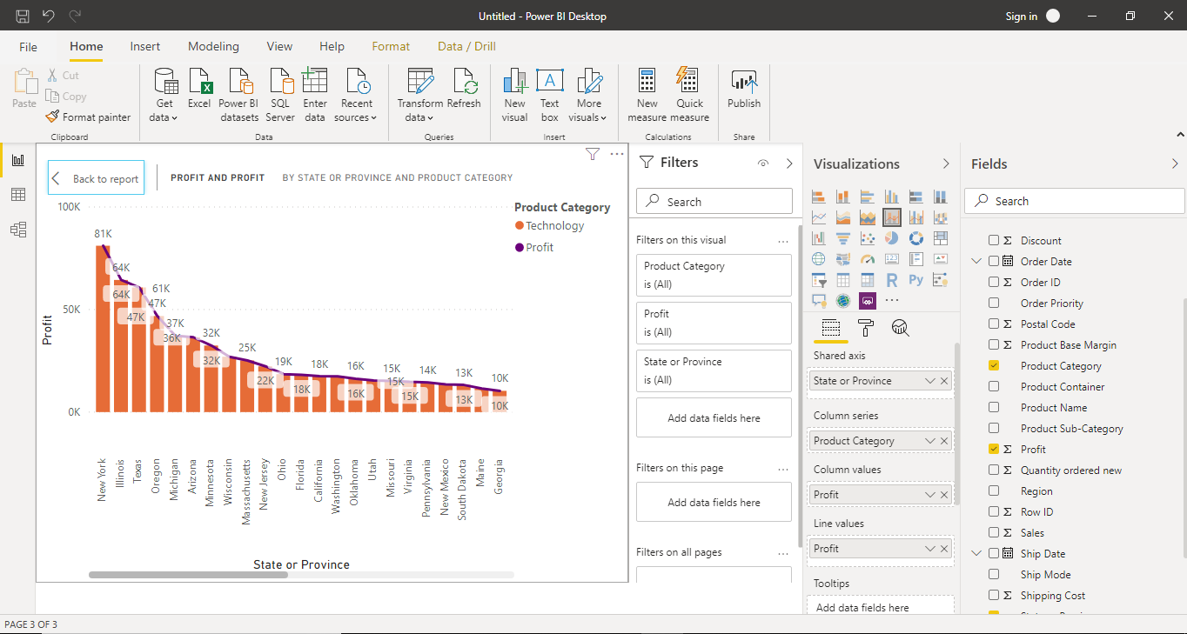

**Q3 • Create a Donut Chart showing sales in terms of Product category**

**A – Donut chart/Pie Chart can be created under visualization category in power BI Desktop and as suggested sales table created as per mentioned category and slicers have been placed for filtering the data based on conditions.**

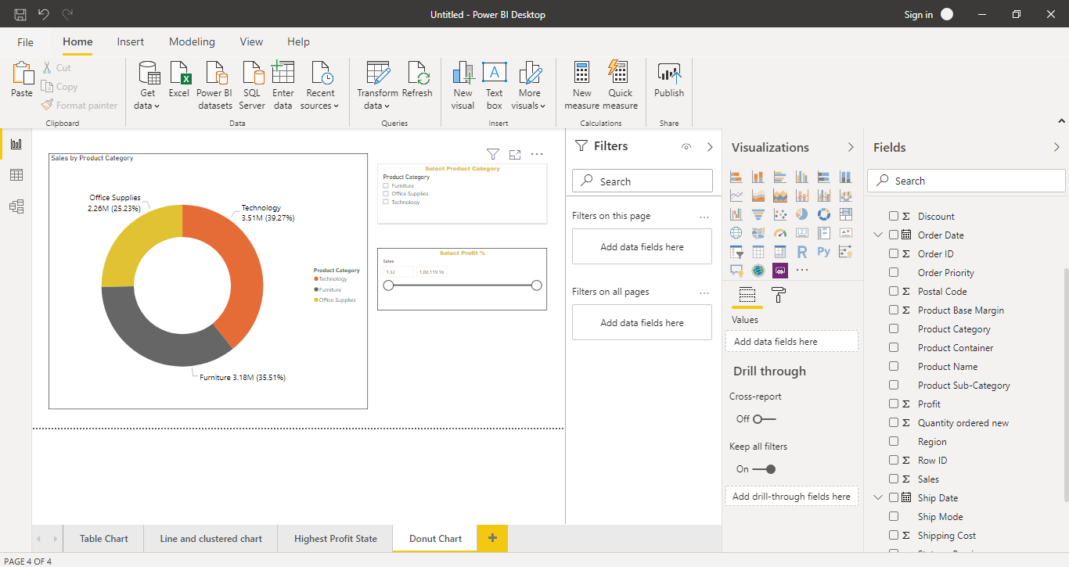

**Q4• Create a Slicer and show the regions in dropdown. See how all the visuals mentioned above behaving when a particular region is selected.**

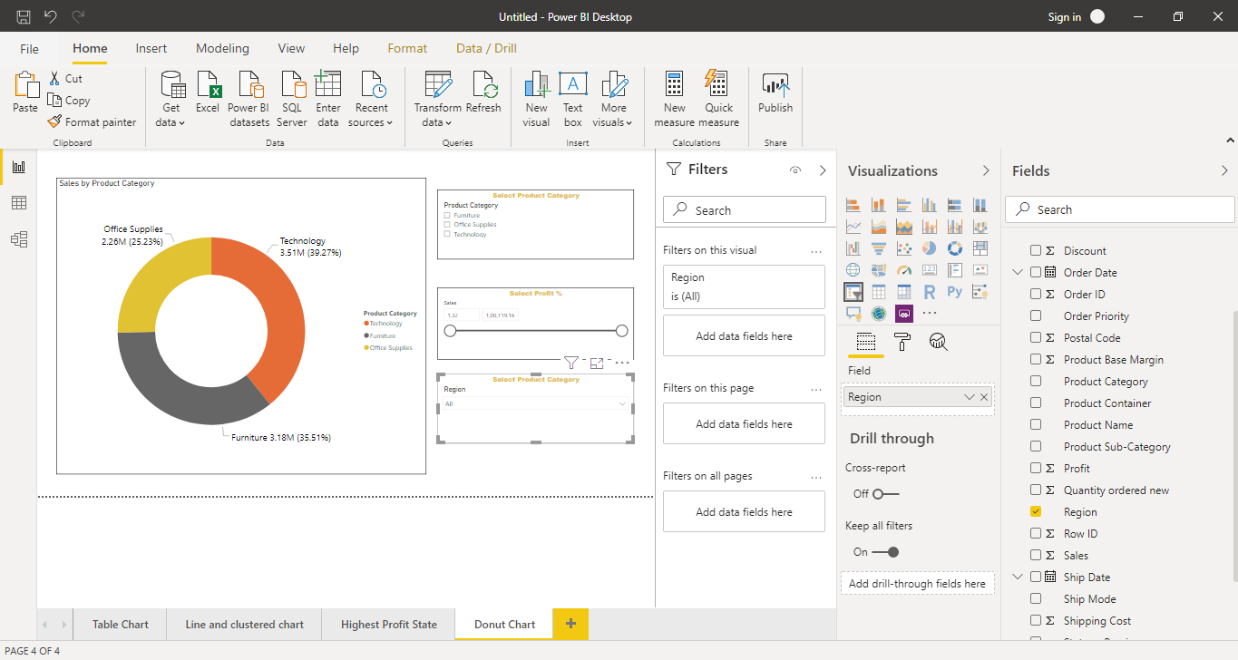

**Visual changed when particular region selected from the drop down and please find the image below :**

